

MUMBAI EDUCATIONAL TRUST
MET INSTITUTE OF COMPUTER SCIENCE

Program Number | 03
Roll Number | 1550
Title of program | Sorting  Projection  Creating Views in MongoDB  Performing Joins Using $lookup  Creating and Managing Indexes in MongoDB
Objective | Sorting  Projection  Creating Views in MongoDB  Performing Joins Using $lookup  Creating and Managing Indexes in MongoDB

1)sorting the documents
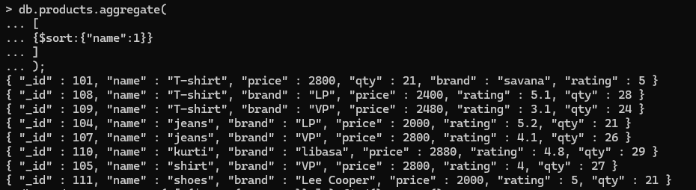

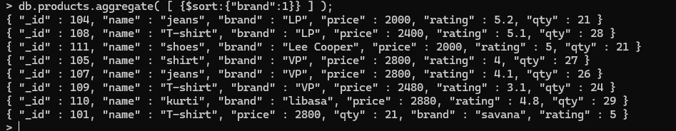
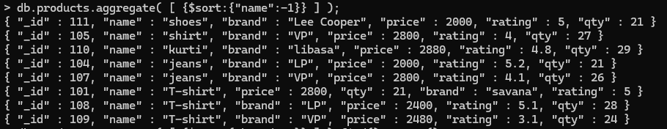
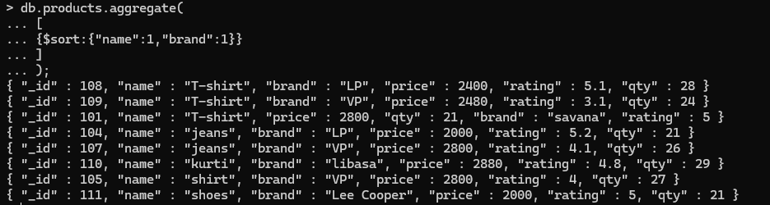

Write a query to find all the products whose quantity is greater than 15 and sort them in descending order of quantity
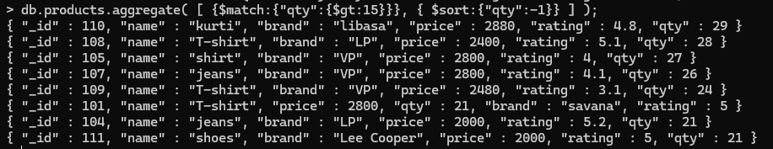

2)Projection in MongoDB
The projection operation is allow you to only select specific field to retrieve document rather than fetching entire document

Write a query to display the name of the product along with its quantity.
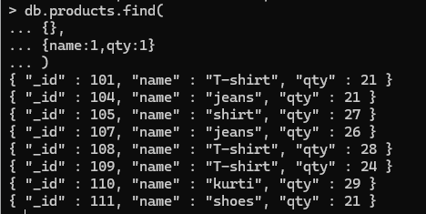

Do not display product id
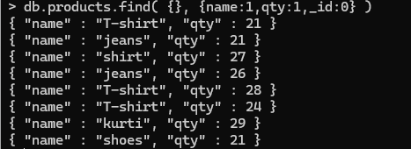
Display the name and brand of product whose quantity is greater than 25
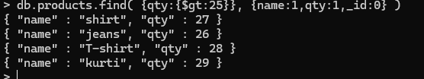

3)View
A view is read only queryable object whose contents are define by an aggregations pipeline.
The MongoDB does not persist on the disk.A views contents computed on demand on client when client queries the view
1)create a collection a Teacher Collection with name ,age ,salary and years of experience

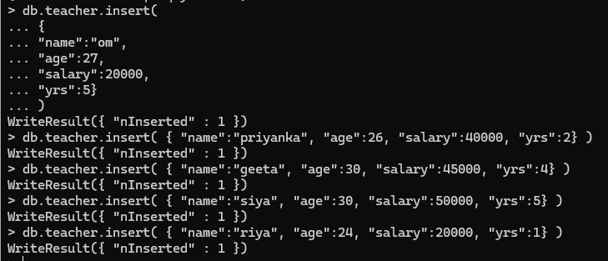
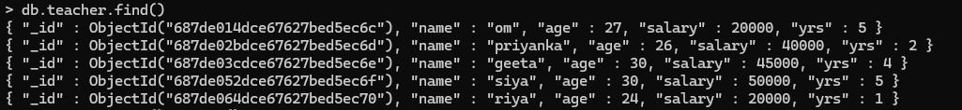
Create a view of teacher whose age is less than 30
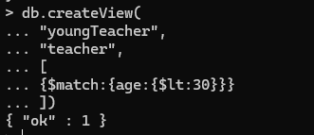
Create a view to display all the products from all the formalShirt
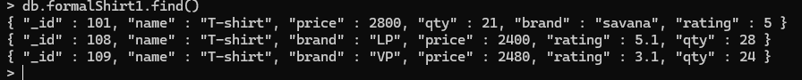

4)Joins in MongoDB
Joins in mongoDb are perform lookup operation it allow to join 2 or more collection can be done using aggregation pipeline
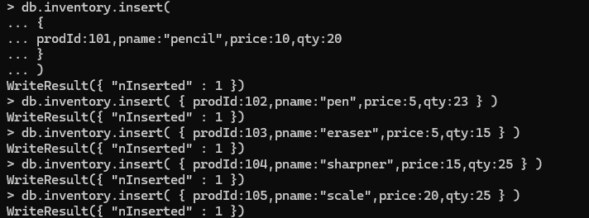
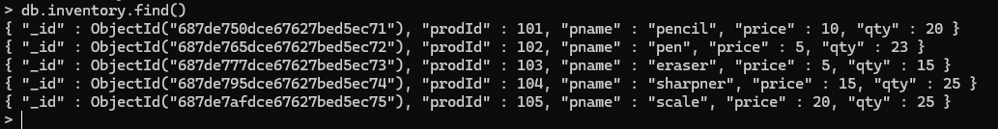
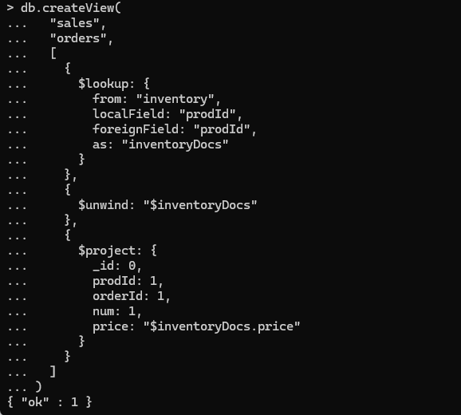

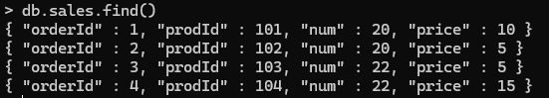
Drop a view
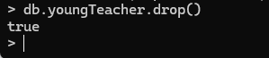

5)Index
An index support efficient execution of query
An index is a special data structure that store sub set of data in a way that allows mongoDB to quickly locate documents in a collection
With index mongoDB does have to scan the entire collection but instead uses an index to directly find relevant data.

Create index
